DATA LOADING IN SNOWFLAKE
FILE FORMATING
In the last post we had seen copy transformations and with the extension of it, I would also apply file formatting
Let’s do some hands on
Create an external stage, table and copy the file data into the table ‘contacts’ as we had seen earlier (to not waste time, I am directly jumping in the table as shown)
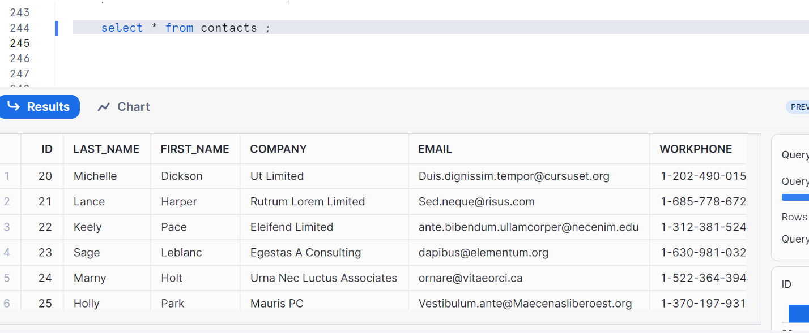
We can create file format as schema objects
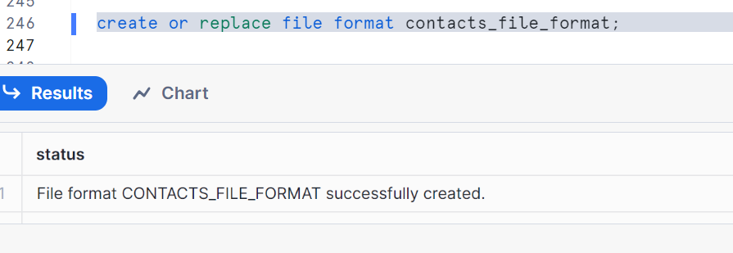

Check the properties of file format
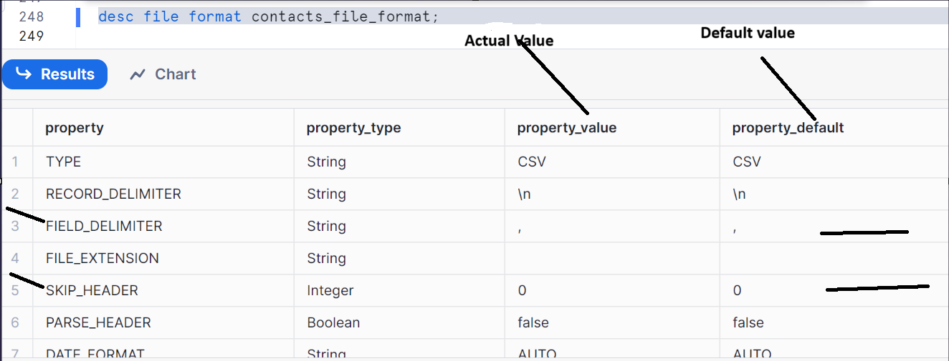
Now, truncating table data to remove Meta data
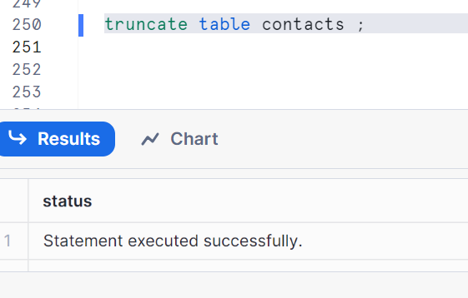
Using file format object below
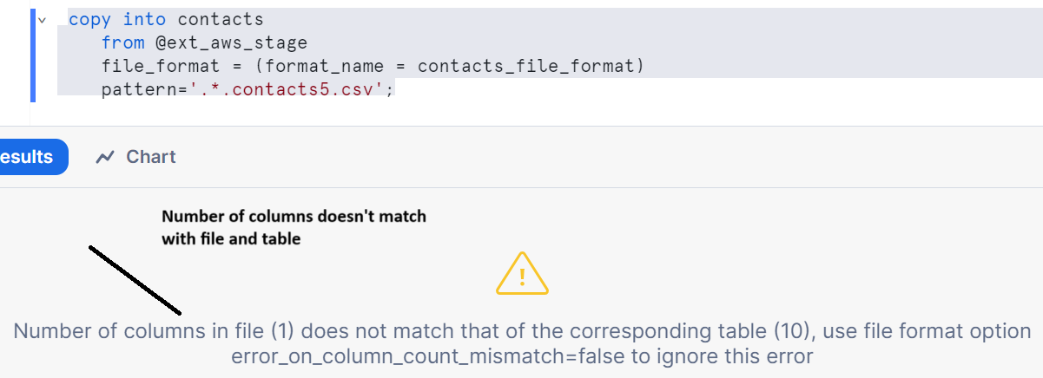

Now to resolve this, we can alter file format object
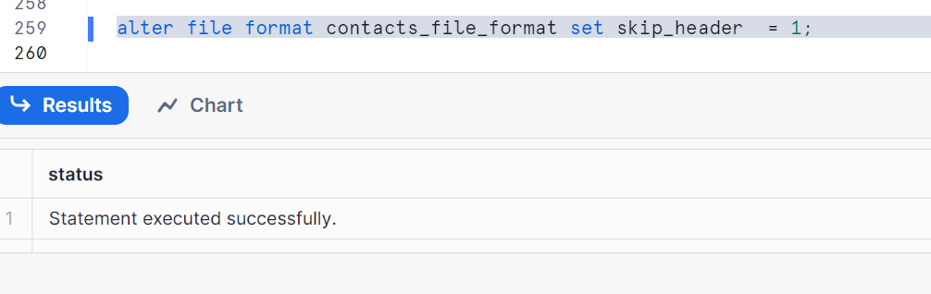
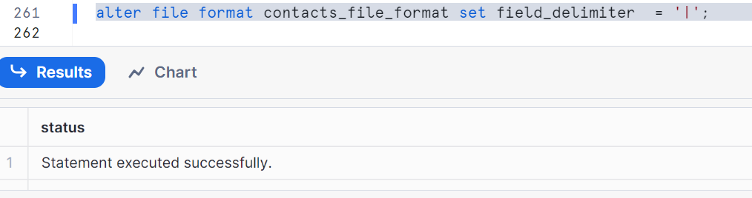
We are changing skip_header=1 and field_delimiter=’|’ where these are the actual parameters to copy the file data
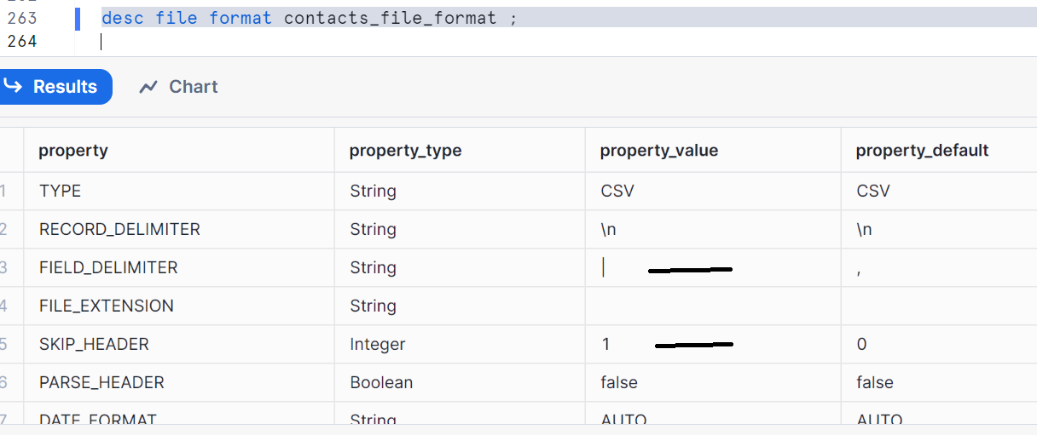

Now running the copy again
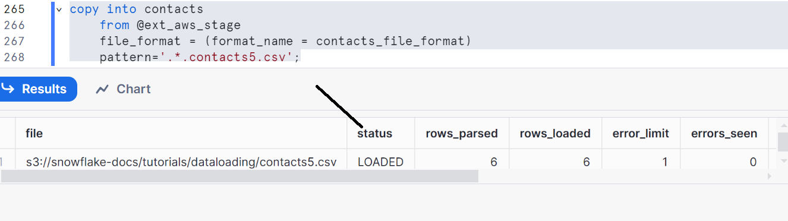
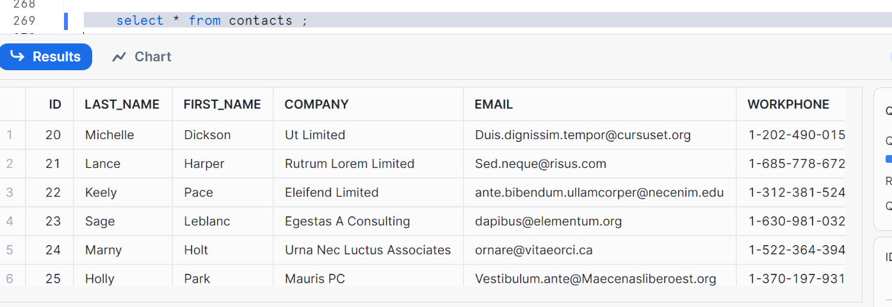
As file format is a database object, u can alter it
Here are some cases
1. Can alter name
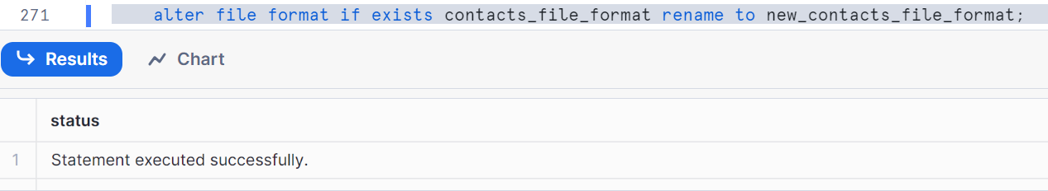
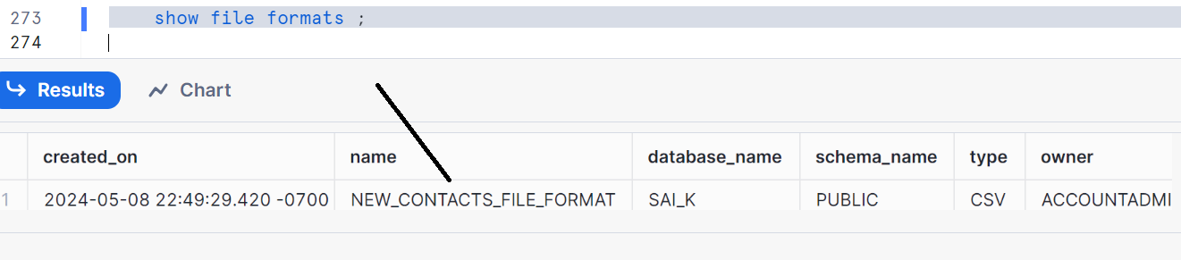
2. Can alter comments.
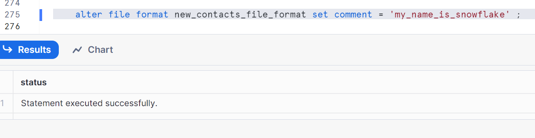
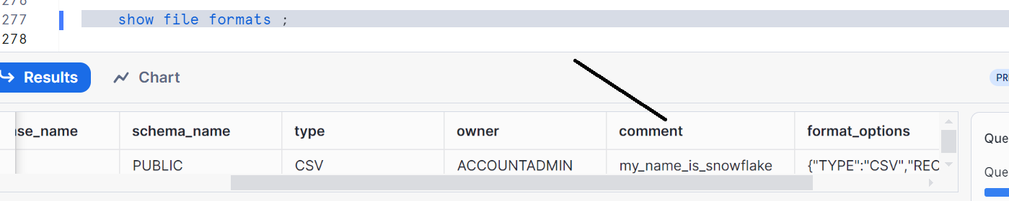
3: Cannot alter TYPE, You need to recreate the file format.
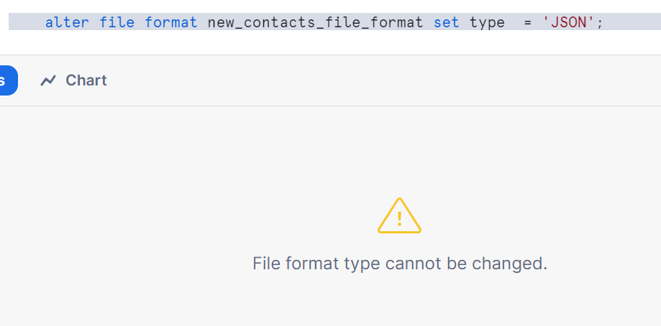

Now let me do the same instead of using alter command
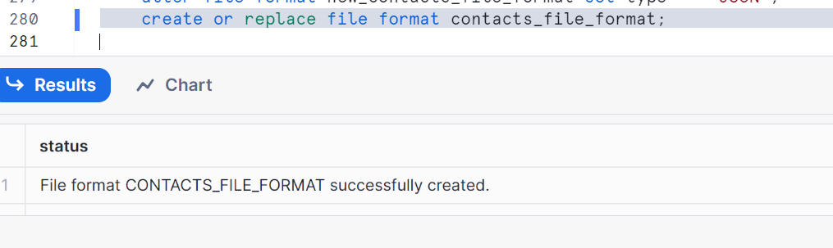
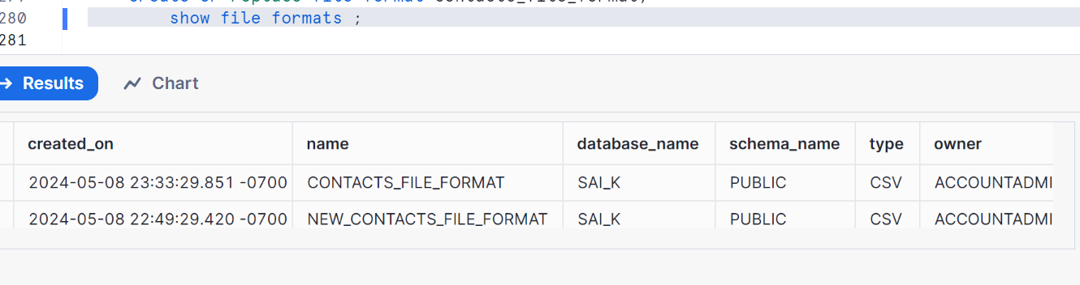
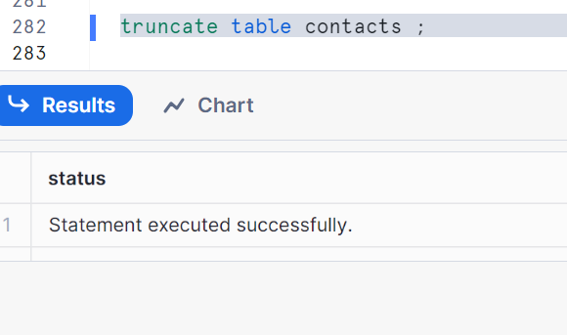

Overwriting properties of file format object
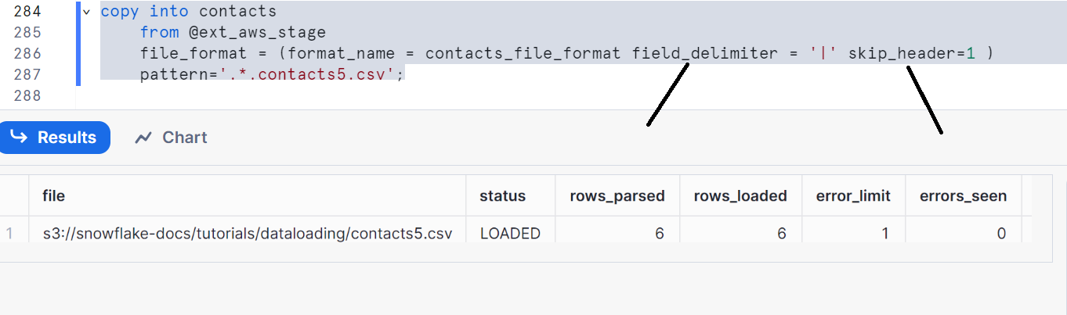
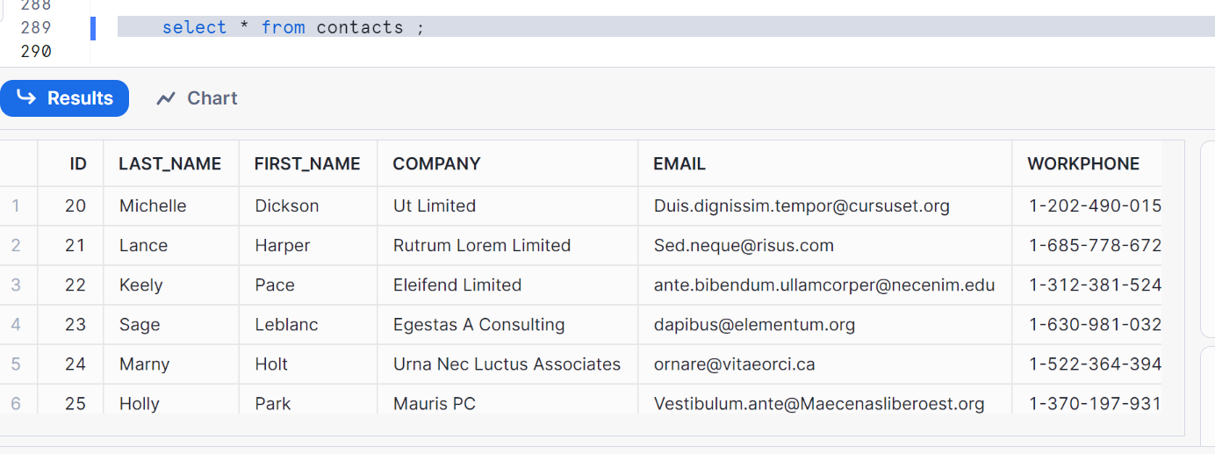

Note:
Properties of stage is a superset, all properties of file format are in stage
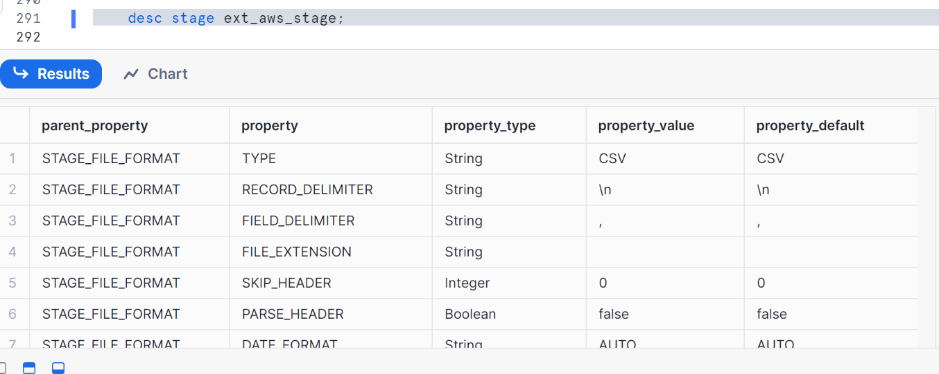
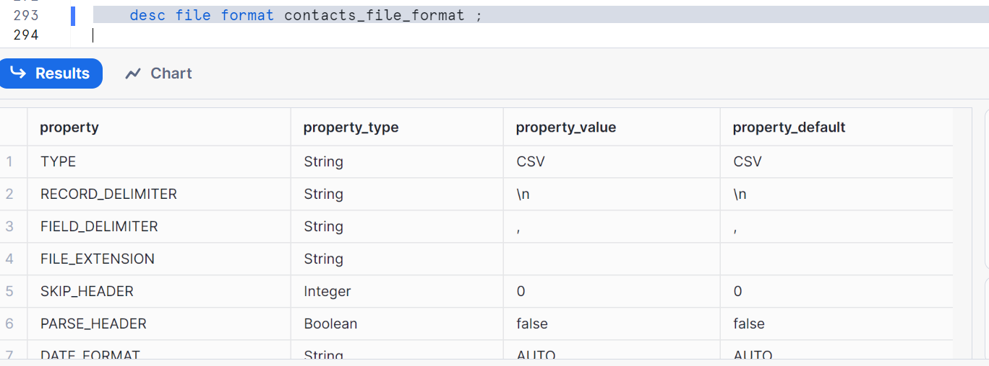
Hence if you don’t give field_delimiter and skip_header in the syntax
By default it takes from the file format properties i.e. field_delimiter =’,’ and skip_header=0

Now let’s clean up
Drop stage if exists ext_aws_stage;
Drop file format contacts_file_format;
Drop table contacts;

